- Write a program to find the point line-line intersection.
Hint: Use the below equations to obtain the intersection.
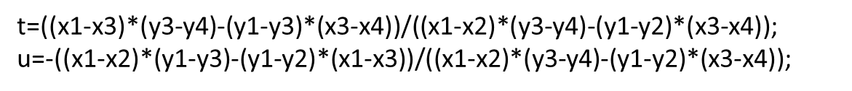
Input : line 1 points (5,5) and (5,30) and Line2 (2,5) and (30,5)
Code:
int x1=5,x2=5,x3=2,x4=30,y1=5,y2=30,y3=5,y4=5;
double p,q;
double t=((x1-x3)*(y3-y4)-(y1-y3)*(x3-x4))/((x1-x2)*(y3-44)-(y1-y2)*(x3-x4));
void setup(){
}
void draw(){
p=x1+t*(x2-x1);
q=y1+t*(y2-y1);
print("[" + p+","+q+"]");
}
Output: [5.0,5.0]
Reference link:
https://www.youtube.com/watch?v=bbTqI0oqL5U&ab_channel=TECHDOSE
http://paulbourke.net/geometry/circlesphere/

- Write a program to ray-sphere intersection.
Input : sphere center and radius
Code:
float x1,x2,y1,y2,z1,z2,a,b,c,r,rx,ry,rz,d;
float t1,t2,fx1,fx2,fy1,fy2,fz1,fz2;
float dn;
void setup(){
r=50;
rx=ry=rz=0;
x1=y2=50;
y1=10;
x2=20;
z1=30;
z2=0;
a=(sq(x2-x1))+(sq(y2-y1))+(sq(z2-z1));
b=-2*(((x2-x1)*(rx-x1))+((y2-y1)*(ry-y1))+((z2-z1)*(rx-z1)));
c=(sq(x1-rx))+(sq(y1-ry))+(sq(z1-rz))-(sq(r));
d=(sq(b))-(4*a*c);
dn=sqrt(d);
}
void draw(){
if(d<0){
print("will not intersect");
}
else if(d==0&&a>0){
t1=-b/(2*a);
fx1=x1+(t1*(x2-x1));
fy1=y1+(t1*(y2-y1));
fz1=z1+(t1*(z2-z1));
print("["+fx1+","+fy1+","+fz1+"]");
}
else{
t1=(-1)*(b+dn)/(2*a);
t2=(-1)*(b-dn)/(2*a);
fx1=x1+(t1*(x2-x1));
fy1=y1+(t1*(y2-y1));
fz1=z1+(t1*(z2-z1));
fx2=x1+(t2*(x2-x1));
fy2=y1+(t2*(y2-y1));
fz2=z1+(t2*(z2-z1));
print("["+fx1+","+fy1+","+fz1+"]");
print("["+fx2+","+fy2+","+fz2+"]");
}
}
Output:
[39.18762,24.41651,19.187618][25.518265,42.642315,5.518265]

